Unicorn Project - SQL Questions & Answers

1. How many customers do we have in the data?

-- There are 795 customers in the database

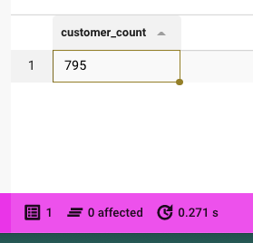

1. What was the city with the most profit for the company in 2015?

-- **ANS -- New York City with 14753**

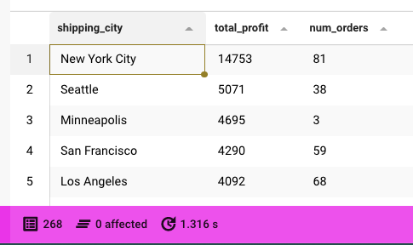

1. In 2015, what was the most profitable city's profit?

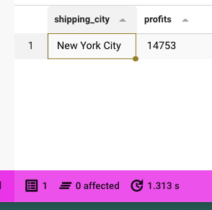

1. How many different cities do we have in the data?

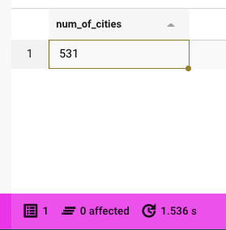

1. Show the total spent by customers from low to high.

-- The lowest amount spent is 11 and the highest amount spent is 1,1320,067

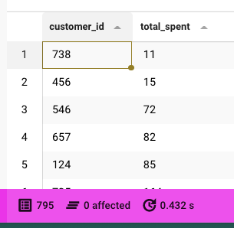

1. What is the most profitable city in the State of Tennessee?

**--ANS-- Lebanon is the most profitable city with $83 profit and 3 orders**

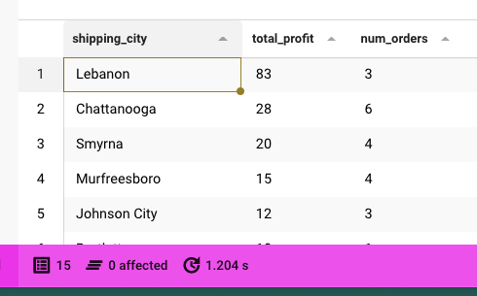

1. What’s the average annual profit for that city across all years?

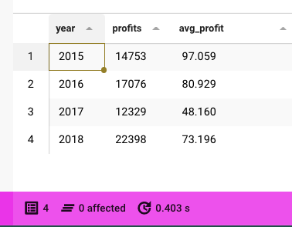

1. What is the distribution of customer types in the data?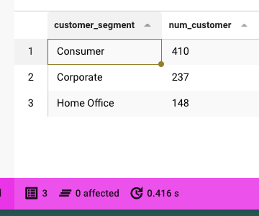
2. What’s the most profitable product category on average in Iowa across all years?

-- The most profitable product category in Iowa is Furniture with an average profit of 130.25 and the least profitable was office supply with 15.73

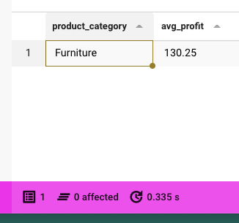

1. What is the most popular product in that category across all states in 2016?

--The most popular product in 'Furniture' Category is Global Push Button Manager's Chair', indigo with 22 qty in 2016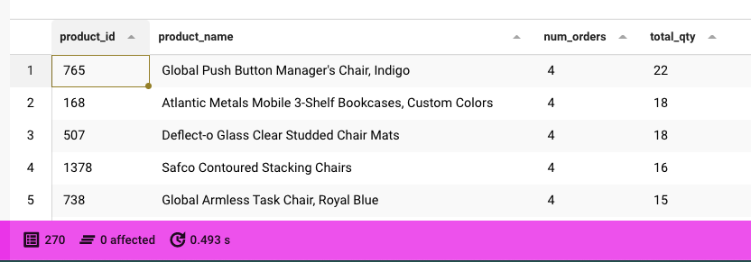

1. Which customer got the most discount in the data? (in total amount).

Ordered by: Total discount = order_discount * order_sales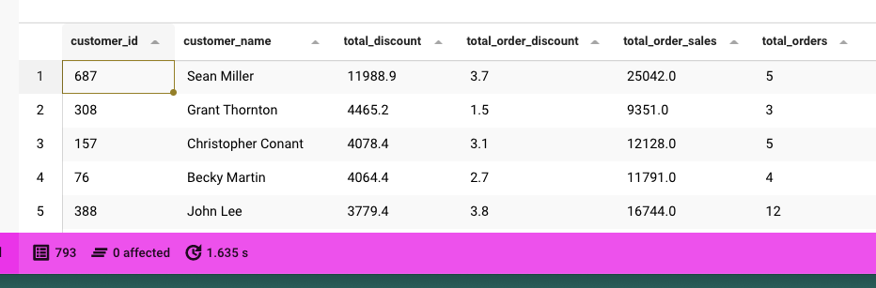

Ordered by: SUM(Total_order_discount)

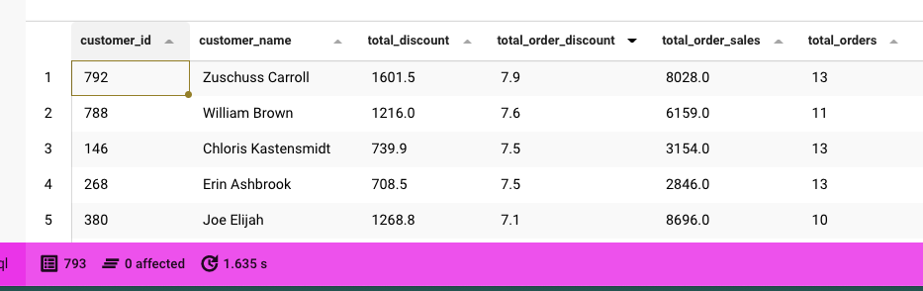

1. How widely did monthly profits vary in 2018? 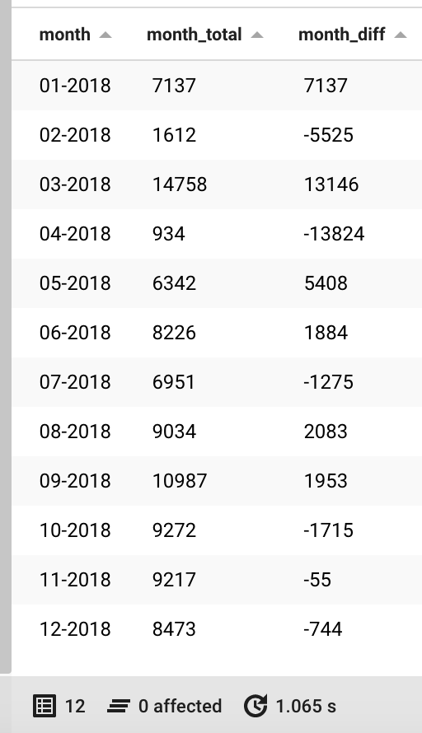

# This one is another code. I also added this yearly change to see how the profit ratio changed.

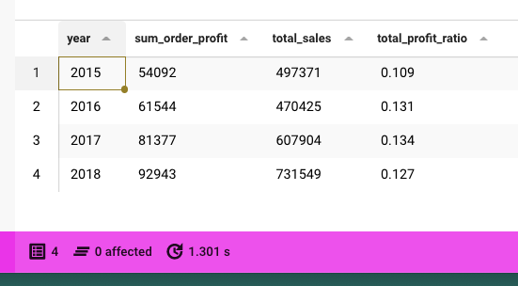

1. Which was the biggest order regarding sales in 2015?

**-- The biggest order sale was from order_id CA-2015-145317 and was 23660. Least was CA-2015-112403 with 1 as sales price**

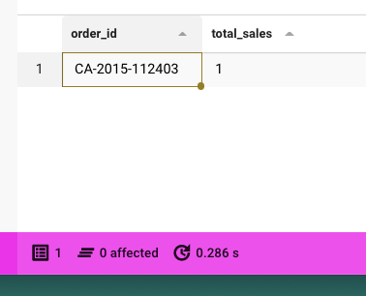

1. What was the rank of each city in the East region in 2015 in quantity?

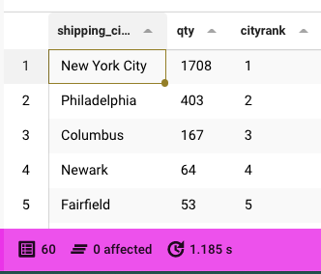

1. Display customer names for customers who are in the segment ‘Consumer’ or ‘Corporate.’ How many customers are there in total?

-- Unique customers by segment

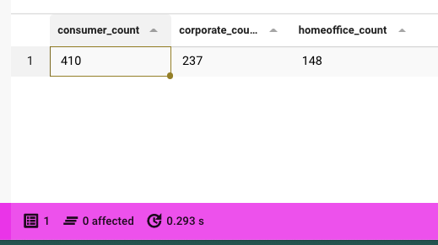

-- List of Consumers or Corporate (alphabetic order first name)

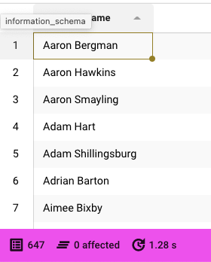

1. Calculate the difference between the largest and smallest order quantities for product id ‘100.’

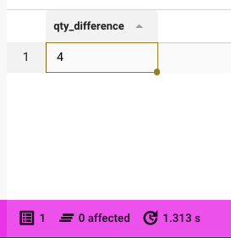

1. Calculate the percent of products that are within the category ‘Furniture.’

-- The percentage of Furniture products is 20.54%.

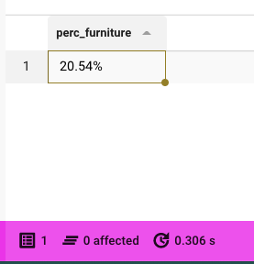

1. Display the number of product manufacturers with more than 1 product in the product table.

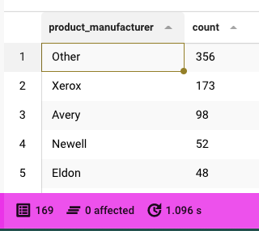

1. Show the product_subcategory and the total number of products in the subcategory. Show the order from *most* to *least* products and then by product_subcategory name ascending.

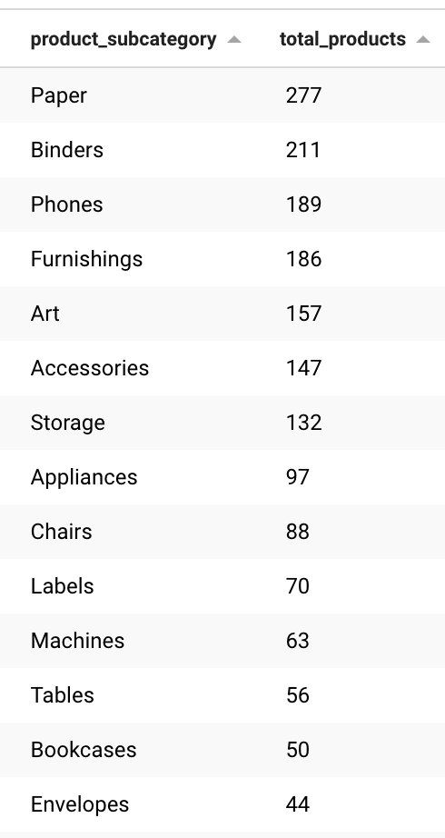

1. Show the product_id(s), the sum of quantities, where the total sum of its product quantities is greater than or equal to 100.

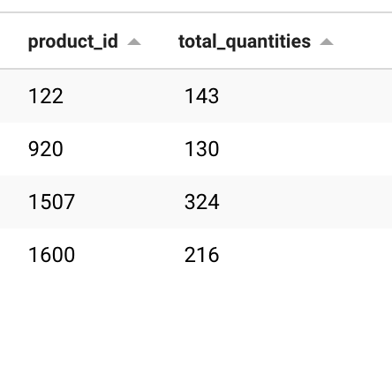

**Bonus question:** Join all database tables into one dataset that includes all unique columns and download it as a .csv file.

WITH CTE_ALL AS (

SELECT

o.*, EXTRACT(YEAR FROM o.order_date) AS year,

od.order_details_id, od.quantity, od.order_discount,

od.order_profits, od.order_profit_ratio, od.order_sales,

c.customer_name, c.customer_segment,

p.*

-- p.product_id, p.product_name, p.product_category, p.product_subcategory, p.product_manufacturer

FROM orders o

JOIN order_details od ON o.order_id = od.order_id

JOIN customers c ON o.customer_id = c.customer_id

JOIN product p ON p.product_id = od.product_id

)

SELECT *

FROM CTE_ALL

;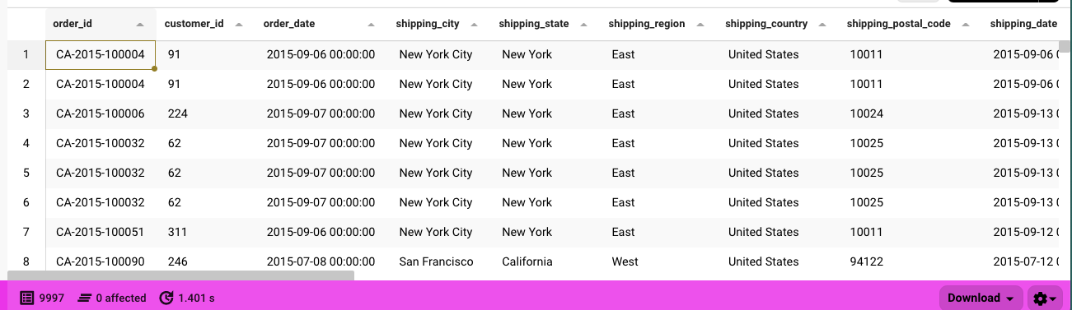

Supplementary Material

**Appendix 1: A list with the questions and the SQL code as used in Beekeeper.**

| **#** | **Question** | **SQL Code** |
| --- | --- | --- |
| 1 | How many customers do we have in the data? | SELECT  COUNT(customer_id) AS customer_count  FROM customers  ; |
| 2 | What was the city with the most profit for the company in 2015? | SELECT o.shipping_city, SUM(od.order_profits) AS Total_profit,  COUNT(DISTINCT o.order_id) AS Num_orders  FROM orders o  LEFT JOIN order_details od ON o.order_id = od.order_id  WHERE EXTRACT (YEAR FROM o.order_date)=2015  GROUP BY 1  ORDER BY 2 DESC  Limit 3  ; |
| 3 | In 2015, what was the most profitable city's profit? | WITH CTE AS (  SELECT *,  EXTRACT(YEAR FROM order_date) AS year  FROM orders  JOIN order_details ON orders.order_id = order_details.order_id  )  -- SELECT * FROM CTE  SELECT shipping_city,  SUM(order_profits) AS profits  FROM CTE  WHERE YEAR = 2015  GROUP BY shipping_city  ORDER BY profits DESC  LIMIT 1; |
| 4 | How many different cities do we have in the data? | SELECT  COUNT(DISTINCT shipping_city) AS Num_of_Cities  FROM orders  ; |
| 5 | Show the total spent by customers from low to high | SELECT cs.customer_id,SUM(od.order_sales * od.quantity) total_spent  FROM customers cs  LEFT JOIN orders o ON cs.customer_id = o.customer_id  LEFT JOIN order_details od ON o.order_id = od.order_id  GROUP BY cs.customer_id  ORDER BY total_spent ; |
| 6 | What is the most profitable city in the State of Tennessee? | SELECT o.shipping_city,  SUM(od.order_profits) AS Total_profit,  COUNT(DISTINCT o.order_id) AS Num_orders  FROM orders o  JOIN order_details od ON o.order_id = od.order_id  WHERE shipping_state LIKE '%Tenne%'  GROUP BY 1  ORDER BY 2 DESC  ; |
| 7 | What’s the average annual profit for that city across all years? | WITH CTE AS (  SELECT *,  EXTRACT(YEAR FROM order_date) AS year  FROM orders  JOIN order_details ON orders.order_id = order_details.order_id  )  SELECT  year,  SUM(order_profits) AS profits,  ROUND(AVG(order_profits::numeric),3) AS avg_profit  FROM CTE  WHERE shipping_city = 'New York City'  GROUP BY year  ORDER BY year ASC  ; |
| 8 | What is the distribution of customer types in the data? | SELECT customer_segment,COUNT(customer_id) AS num_customer  FROM customers  GROUP BY customer_segment  ; |
| 9 | What’s the most profitable product category on average in Iowa across all years? | SELECT p.product_category, AVG(od.order_profits) avg_profit  FROM product p  LEFT JOIN order_details od ON p.product_id = od.product_id  LEFT JOIN orders o ON od.order_id = o.order_id  WHERE shipping_state = 'Iowa'  GROUP BY p.product_category  ORDER BY avg_profit DESC  LIMIT 1; |
| 10 | What is the most popular product in that category across all states in 2016? | SELECT p.product_id, p.product_name, COUNT(DISTINCT o.order_id) As Num_orders, SUM(od.quantity) AS total_Qty  FROM orders o  JOIN order_details od ON o.order_id = od.order_id  JOIN product p ON p.product_id = od.product_id  WHERE EXTRACT (YEAR FROM o.order_date)=2016 AND p.product_category LIKE 'Furniture'  GROUP BY 1,2  ORDER BY 3 DESC, 4 DESC  ; |
| 11 | Which customer got the most discount in the data? (in total amount) | WITH CTE1 AS (  SELECT o.order_id, o.customer_id,  c.customer_name, c.customer_segment,  o.order_date, o.shipping_city, o.shipping_state, o.shipping_mode,  od.order_details_id, od.product_id, od.quantity, od.order_discount,  od.order_profits, od.order_profit_ratio, od.order_sales,  EXTRACT(YEAR FROM o.order_date) AS year,  od.order_sales * od.order_discount AS total_discount  FROM orders o  JOIN order_details od ON o.order_id = od.order_id  JOIN customers c ON o.customer_id = c.customer_id  )  SELECT customer_id, customer_name,  ROUND(SUM(total_discount::numeric), 1) AS total_discount,  ROUND(SUM(order_discount::numeric), 1) AS total_order_discount,  ROUND(SUM(order_sales::numeric), 1) AS total_order_sales,  COUNT(DISTINCT order_id) AS total_orders  FROM CTE1  GROUP BY customer_id, customer_name  ORDER BY total_discount DESC  ; |
| 12 | How widely did monthly profits vary in 2018? | WITH CTE AS (  SELECT TO_CHAR(order_date,'MM-YYYY') AS month,  SUM(order_profits) AS month_total  FROM order_details  JOIN orders  ON orders.order_id = order_details.order_id  WHERE date_part('year',order_date) = '2018'  GROUP BY month  ORDER BY month )  SELECT *, (month_total - LAG(month_total,1,0) OVER () ) AS month_diff  FROM cte  -- # Alternative code. I also added early change to see how the profit ratio changed.  SELECT EXTRACT( YEAR FROM o.order_date) AS year,  SUM(od.order_profits) AS sum_order_profit,  SUM(od.order_sales) AS total_sales,  ROUND((SUM(od.order_profits)/SUM(od.order_sales))::NUMERIC,3) AS total_profit_ratio  FROM order_details od  LEFT JOIN orders o ON od.order_id = o.order_id  GROUP BY year  ORDER BY year  ; |
| 13 | Which was the biggest order regarding sales in 2015? | SELECT o.order_id, SUM(od.order_sales) total_sales  FROM order_details od  LEFT JOIN orders o ON od.order_id = o.order_id  WHERE EXTRACT(YEAR FROM o.order_date) = 2015  GROUP BY o.order_id  ORDER BY total_sales --DESC  LIMIT 1; |
| 14 | What was the rank of each city in the East region in 2015 in quantity? | SELECT  o.shipping_city,  SUM(od.quantity) AS Qty,  RANK() OVER (ORDER BY SUM(quantity) DESC) AS cityrank  FROM orders o  JOIN order_details od ON o.order_id = od.order_id  WHERE shipping_region = 'East' AND EXTRACT (YEAR FROM o.order_date)=2015  GROUP BY o.shipping_city  ; |
| 15 | Display customer names for customers who are in the segment ‘Consumer’ or ‘Corporate.’ How many customers are there in total? | -- Ensuring unique customers with CASE WHEN (Quicker)  SELECT  COUNT(DISTINCT CASE WHEN customer_segment = 'Consumer' THEN customer_id END) AS Consumer_count,  COUNT(DISTINCT CASE WHEN customer_segment = 'Corporate' THEN customer_id END) AS Corporate_count,  COUNT(DISTINCT CASE WHEN customer_segment = 'Home Office' THEN customer_id END) AS HomeOffice_count  FROM customers  ;  -- List of Consumers or Corporate (alphabetic order first name)  SELECT customer_name  FROM customers  WHERE customer_segment IN ('Consumer', 'Corporate')  GROUP BY customer_name  ORDER BY customer_name ASC  ; |
| 16 | Calculate the difference between the largest and smallest order quantities for product id ‘100.’ | SELECT  (MAX(quantity)-MIN(quantity)) AS qty_difference  FROM order_details  WHERE product_id = 100  ; |
| 17 | Calculate the percent of products that are within the category ‘Furniture.’ | SELECT CONCAT(ROUND((SELECT COUNT(product_category):: NUMERIC  FROM product  WHERE product_category = 'Furniture'  GROUP BY product_category)/COUNT(product_category)*100,2),'%') perc_furniture  FROM product  ; |
| 18 | Display the number of product manufacturers with more than 1 product in the product table. | SELECT product_manufacturer,  COUNT(DISTINCT product_id)  FROM product  GROUP BY 1  HAVING COUNT(DISTINCT product_id)>1  ORDER BY 2 DESC  ; |
| 19 | Show the product_subcategory and the total number of products in the subcategory. Show the order from most to least products and then by product_subcategory name ascending. | SELECT  product_subcategory,  COUNT(*) AS total_products  FROM product  GROUP BY product_subcategory  ORDER BY total_products DESC, product_subcategory ASC  ; |
| 20 | Show the product_id(s), the sum of quantities, where the total sum of its product quantities is greater than or equal to 100. | SELECT product_id,  SUM(quantity) AS total_quantities  FROM order_details  WHERE quantity >= 100  GROUP BY product_id  ; |
| 21 | Bonus question: Join all database tables into one dataset that includes all unique columns and download it as a .csv file | WITH CTE_ALL AS (  SELECT  o.*, EXTRACT(YEAR FROM o.order_date) AS year,  od.order_details_id, od.quantity, od.order_discount,  od.order_profits, od.order_profit_ratio, od.order_sales,  c.customer_name, c.customer_segment,  p.*  -- p.product_id, p.product_name, p.product_category, p.product_subcategory, p.product_manufacturer  FROM orders o  JOIN order_details od ON o.order_id = od.order_id  JOIN customers c ON o.customer_id = c.customer_id  JOIN product p ON p.product_id = od.product_id  )  SELECT *  FROM CTE_ALL  ; |